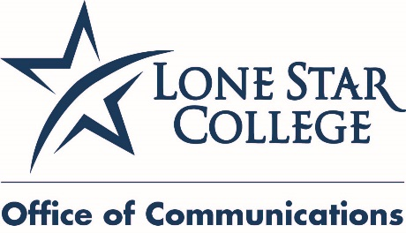
June 1, 2017
FOR IMMEDIATE RELEASE

Media Contacts:

Bill Van Rysdam
832.813.6206, desk
Bill.VanRysdam@LoneStar.edu

Jed T. Young
832.813.6521, desk
281.974.6878, cell
Jed.T.Young@LoneStar.edu

Lone Star College-Small Business Development Center seeks nominations for awards

HOUSTON (June 1, 2017) – The Lone Star College-Small Business Development Center is accepting nominations for the 31st Annual Small Business of the Year Awards which will be held Nov. 9 in the Lone Star Community Building.

“We are very happy to celebrate and recognize our small businesses and owners throughout the Lone Star College service area,” said Miguel Lopez, LSC-SBDC executive director. “Their success and economic impact are key to the local communities and economies in Harris and Montgomery Counties.”

Each year, members of the LSC-SBDC Advisory Council recognize successful small businesses that have an impact in the local community and economy. Click here to learn more and nominate a small business.

Winners are chosen based on leadership, entrepreneurial spirit, business growth and success, and a meaningful contribution to the community. Finalists are chosen from the LSC service area and will be selected from each of the different small business of the year categories: woman-owned, veteran-owned, family-owned, young entrepreneur, home-based, minority-owned, and the Lone Star College Small Business Owner of the Year.

Each category will have three finalists and ultimately one winner will be named per category. The deadline for nomination entries is July 10.
“We added categories this year to ensure we encompass different types of businesses. We also added a new award this year that will go to the chamber of commerce that submits the most qualified nominations,” said Lopez.

The LSC-SBDC works with companies to help them become established, grow, survive and succeed by providing professional management consulting and training. SBDC services are available for companies in every phase of the business life cycle. For more information about the SBDC visit SBDC.LoneStar.edu.

Known for its leadership, innovation and steadfast commitment to student success, Lone Star College provides high-quality academic transfer and workforce education / career training programs to more than 83,000 credit students each semester, and a total enrollment of 95,000 students. LSC is training tomorrow’s workforce today and redefining the community college experience to promote student success and economic prosperity. Stephen C. Head, Ph.D., is the chancellor of LSC, the largest institution of higher education in the Houston area, which consists of six colleges, eight centers, two university centers, Lone Star Corporate College and LSC-Online. To learn more visit LoneStar.edu.

####

