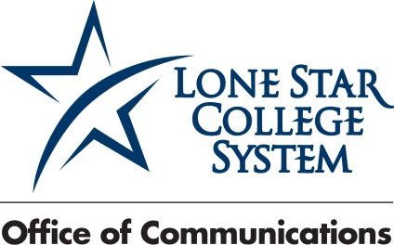
Nov. 25, 2014
FOR IMMEDIATE RELEASE
PHOTOS AND CUTLINES INCLUDED
HI-DEF PHOTOS OF INDIVIDUAL WINNERS AVAILABLE

Media Contacts:
Jed T. Young
832.813.6521, desk
281.974.6878, cell
Jed.T.Young@LoneStar.edu

Bill Van Rysdam
832.813.6206, desk
Bill.VanRysdam@LoneStar.edu

Lone Star College SBDC announces winners for 2014 Small Business awards

HOUSTON (Nov. 25, 2014) – The Lone Star College Small Business Development Center Advisory Council has named its six 2014 Small Business of the Year Award winners.

The winners, one representing each of the six Lone Star Colleges, were honored Thursday, Nov. 20, at the SBDC Advisory Council’s 28th Annual Small Business of the Year Awards Banquet held at The Woodlands Waterway Marriott. This year’s awards were sponsored by BBVA Compass Bank.

Stephen Head, LSC chancellor, welcomed guests and the business owners as part of the event, which included more than 340 in attendance.

“Lone Star College understands the challenges small businesses owners face and is proud to play a part in helping them succeed,” said Head. “These small businesses are vital to the local economy and all the finalists and winners should be proud of what they have accomplished.”

The 2014 28th Annual Small Business of the Year award was given to:

- Langham Creek Ace Hardware – Chuck and Arlene O’Malley, representing the LSC-CyFair area.

- Red Door Realty & Associates – Jill Henderson and Christi Harvey, representing the LSC-Kingwood area.

- Karlins Ramey & Tompkins, LLC – Mike Karlins and Jay Tompkins, representing the LSC-Montgomery area.

- AEI Engineering, LLC – Nancy Blackwell, Michael Kurzy and John T. Matkin, representing the LSC-North Harris area.

- Klein Wealth Management – Lori Klein, representing the LSC-Tomball area.

- Register Real Estate Advisors – Shannon and Matt Register, representing the LSC-University Park area.

“The Small Business Development Center is proud to support all small business owners and help them to evolve to the next level,” said Sal Mira, executive director of the SBDC.

Each year, the LSC SBDC Advisory Council recognizes successful small businesses that make an impact in the local community. More than 200 nominees were gathered from the community and narrowed down to the 18 finalists. The finalists were selected by the 18 members of the advisory council on the basis of leadership, entrepreneurial spirit, business growth and contribution to the community.

The LSC SBDC works with companies to help them grow and compete in today's global economy. SBDC services are available for companies in every phase of the business life cycle, helping entrepreneurs make sound decisions and succeed. For more information about the SBDC visit sbdc.LoneStar.edu.

Lone Star College has been opening doors to a better community for more than 40 years. Founded in 1973, LSC remains steadfast in its commitment to student success and credential completion. Today, with almost 83,000 students in credit classes, and a total enrollment of more than 95,000, Lone Star College is the largest institution of higher education in the Houston area and one of the fastest-growing community colleges in the nation. Stephen C. Head, Ph.D., is the chancellor of LSC, which consists of six colleges including LSC-CyFair, LSC-Kingwood, LSC-Montgomery, LSC-North Harris, LSC-Tomball and LSC-University Park, seven centers, LSC-University Center at Montgomery, LSC-University Center at University Park, Lone Star Corporate College, and LSC-Online. To learn more visit LoneStar.edu.
####

Photo: LSC_SBDC_AwardWinners


Photo cutline: The Lone Star College Small Business Development Center Advisory Council named the six 2014 Small Business of the Year Award winners at the 28th annual Small Business Awards Banquet.

Photo: LSC SBDC LSC-CyFair Winner
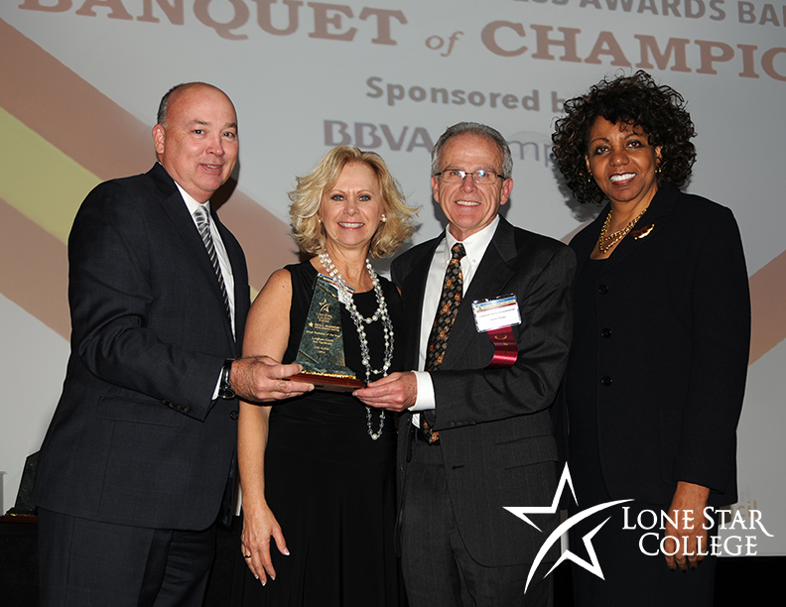
Photo cutline: Langham Creek Ace Hardware receives the 2014 Small Business of the Year Award, Lone Star College-CyFair, at the 28th annual Small Business Awards Banquet. Shown here (left - right) are Stephen Head, chancellor Lone Star College; Chuck and Arlene O’Malley of Langham Creek Ace Hardware; and Dr. Audre Levy, president Lone Star College-CyFair, who made the presentation.

Photo: LSCS SBDC LSC-Kingwood Winner
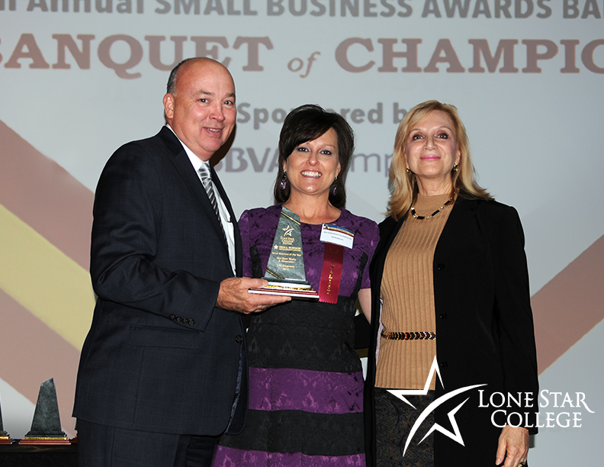
Photo cutline: Red Door Realty & Associates receives the 2014 Small Business of the Year Award, Lone Star College-Kingwood, at the 28th annual Small Business Awards Banquet. Shown here (left - right) are Stephen Head, chancellor Lone Star College; Jill Henderson of Red Door Realty & Associates; and Dr. Rebecca Riley, vice president of academic instruction, Lone Star College-Kingwood, who made the presentation.

Photo: LSC SBDC LSC-Montgomery Winner
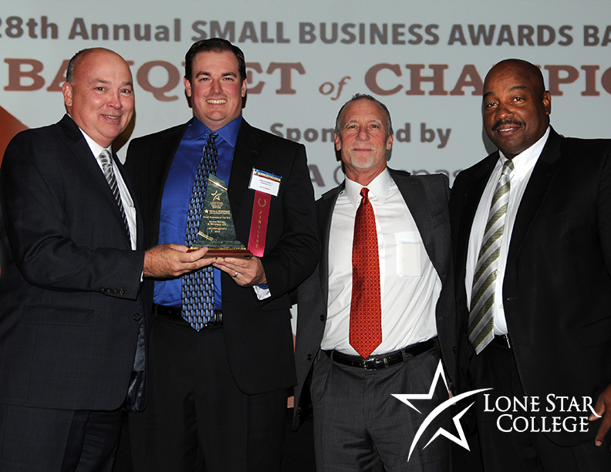
Photo cutline: Karlins Ramey & Tompkins, LLC receives the 2014 Small Business of the Year Award, Lone Star College-Montgomery, at the 27th annual Small Business Awards Banquet. Shown here (left - right) are Stephen Head, chancellor Lone Star College; Jay Tompkins and Mike Karlins of Karlins Ramey & Tompkins, LLC; and Wendell Williams, vice president student success, Lone Star College-Montgomery, who made the presentation.

Photo: LSC SBDC LSC-North Harris
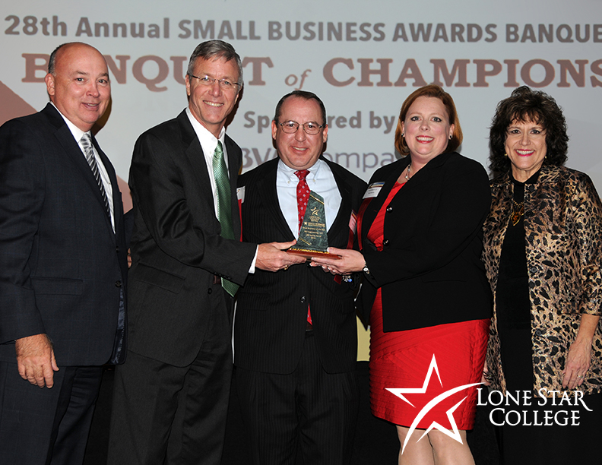
Photo cutline: AEI Engineering, LLC receives the 2014 Small Business of the Year Award, Lone Star College-North Harris, at the 28th annual Small Business Awards Banquet. Shown here (left - right) are Stephen Head, chancellor Lone Star College; John T. Matkin, Michael Kurzy and Nancy Blackwell of AEI Engineering, LLC; and Penny Westerfeld, interim president Lone Star College-North Harris, who made the presentation.

Photo: LSC SBDC LSC-Tomball
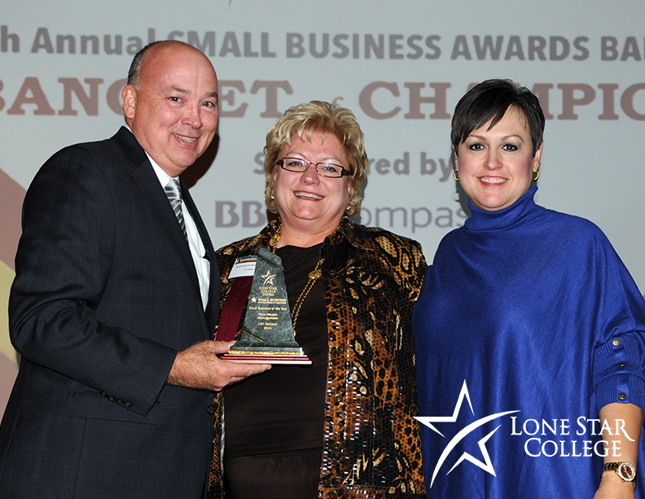
Photo cutline: Klein Wealth Management receives the 2014 Small Business of the Year Award, Lone Star College-Tomball, at the 28th annual Small Business Awards Banquet. Shown here (left - right) are Stephen Head, chancellor Lone Star College; Lori Klein of Klein Wealth Management; and Dr. Lee Ann Nutt, acting president Lone Star College-Tomball, who made the presentation.

Photo: LSC SBDC University Park
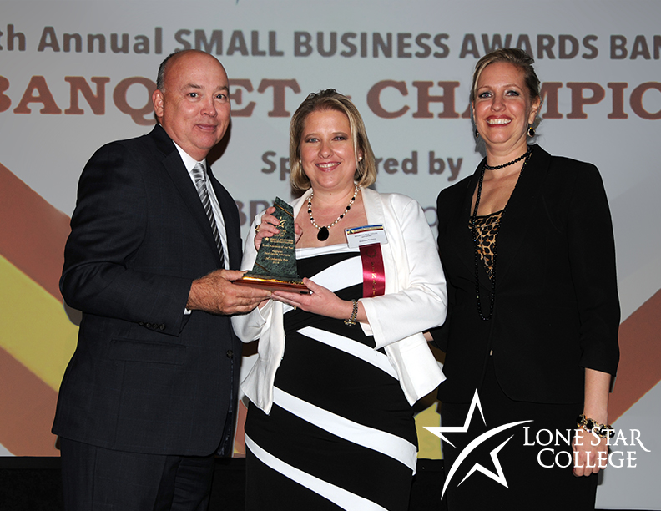
Photo cutline: Register Real Estate Advisors receives the 2014 Small Business of the Year Award, Lone Star College-University Park, at the 28th annual Small Business Awards Banquet. Shown here (left - right) are Stephen Head, chancellor Lone Star College; Shannon Register of Register Real Estate Advisors; and Christina Robinson Grochett, chief strategist - innovation/research Lone Star College-University Park, who made the presentation.

