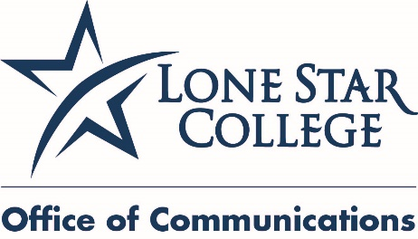

Dec. 6, 2016
FOR IMMEDIATE RELEASE
PHOTOS OF WINNERS AVAILABLE

Media Contacts:

Bill Van Rysdam
832.813.6206, desk
Bill.VanRysdam@LoneStar.edu

Jed T. Young
832.813.6521, desk
281.974.6878, cell
Jed.T.Young@LoneStar.edu

Lone Star College SBDC names 2016 Small Business of the Year winners

HOUSTON (Dec. 6, 2016) – The Lone Star College Small Business Development Center Advisory Council named its six 2016 Small Business of the Year Award winners.

The winners, one representing each of the six Lone Star Colleges, were announced at the SBDC Advisory Council’s 30th Annual Small Business of the Year Awards Banquet held at The Woodlands Waterway Marriott, Thursday, Nov. 18. This year’s awards were sponsored by BBVA Compass Bank.

The event included more than 340 guests and business owners who were welcomed by Stephen C. Head, LSC chancellor.

“Small businesses play such an important role in our community, representing 99 percent of all employer firms,” said Head. “Tonight, we recognize the best of the best, six successful small business owners, one from each of the Lone Star College areas.”

The 2016 30th Annual Small Business of the Year award was given to:

- Mathnasium of Cy-Fair – John and Dr. Catherine Labuda, representing the LSC-CyFair area.

- Minuteman Press – Connie and Darryal Chandler, representing the LSC-Kingwood area.

- Better Bookkeepers – Melanie Bush and Barry Blanton, representing the LSC-Montgomery area.

- Mirror Lake Designs – Michael Shawn Kelly and Blinda Ann Kelly, representing the LSC-North Harris area.

- Massage Envy Tomball – Mack and Michelle Miller, representing the LSC-Tomball area.

- Shredding on the Go – James Parker, representing the LSC-University Park area.

In addition to announcing the winners, the Small Business Development Center recognized the efforts of its director, Sal Mira, who will retire in Jan. 2017. Rep. Kevin Brady’s office presented Mira a U.S. flag which was flown over the capitol. In addition, a LSC scholarship endowment was created in his honor by the LSC Office of External Affairs, the LSC SBDC and the SBDC Advisory Council. Mira served as director for 10 years.

“I would personally like to thank Sal for his work with the Small Business Development,” said Head. “His efforts have helped numerous businesses in our community thrive and be successful.”

The LSC SBDC Advisory Council recognizes successful small businesses that make an impact in the local community each year. More than 200 nominees were submitted from the community and narrowed down to the 18 finalists. The finalists were selected by the 18 members of the advisory council on the basis of leadership, entrepreneurial spirit, business growth and contribution to the community.

The LSC SBDC works with companies to help them grow and compete in today's global economy. SBDC services are available for companies in every phase of the business life cycle, helping entrepreneurs make sound decisions and succeed. For more information about the SBDC visit sbdc.LoneStar.edu.

Lone Star College offers high-quality, low-cost academic transfer and career training education to 98,000 students each semester. LSC is training tomorrow’s workforce today and redefining the community college experience to support student success. Stephen C. Head, Ph.D., serves as chancellor of LSC, the largest institution of higher education in the Houston area with an annual economic impact of $3.1 billion. LSC consists of six colleges, eight centers, two university centers, Lone Star Corporate College and LSC-Online. To learn more, visit LoneStar.edu.
####

Photo: LSC_2016SBDCAwardWinners_LSC-CyFair
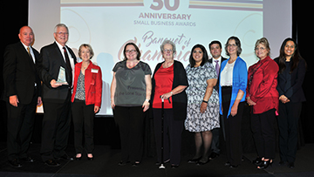
Photo cutline: Mathnasium of CyFair receives the 2016 Small Business of the Year Award, Lone Star College-CyFair, at the 30th annual Small Business Awards Banquet. Shown here (left - right) are Dr. Stephen Head, chancellor Lone Star College; John and Dr. Catherine Labuda, Mathnasium of CyFair employees; and Dr. Keshvala Deana Sheppard, interim president Lone Star College-CyFair, who made the presentation.

Photo: Photo: LSC_2016SBDCAwardWinners_LSC-Kingwood
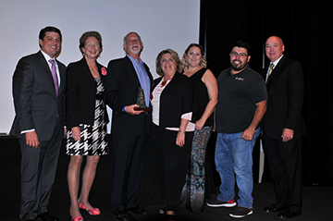
Photo cutline: Minuteman Press receives the 2016 Small Business of the Year Award, Lone Star College-Kingwood, at the 30th annual Small Business Awards Banquet. Shown here (left - right) are Amos McDonald, vice chancellor, external affairs Lone Star College; Dr. Katherine Persson, president, Lone Star College-Kingwood, who made the presentation; Darryal and Connie Chandler, Minuteman Press employees; and Dr. Stephen C, Head, chancellor, Lone Star College.

Photo: Photo: LSC_2016SBDCAwardWinners_LSC-Montgomery
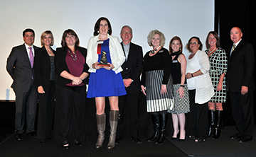
Photo cutline: Better Bookkeepers received the 2016 Small Business of the Year Award for the Lone Star College-Montgomery service area at the 30th annual Small Business Awards Banquet. Pictured are Better Bookkeepers winners with Amos McDonald, vice chancellor, external affairs, Lone Star College, left; Dr. Rebecca Riley, president, Lone Star College-Montgomery, who made the presentation, second from left: and Dr. Stephen C, Head, chancellor, Lone Star College, far right.

Photo: Photo: LSC_2016SBDCAwardWinners_LSC-North Harris
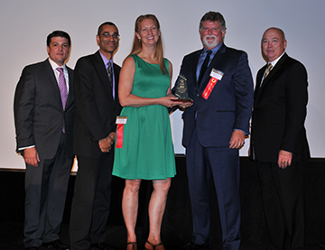
Photo cutline: Mirror Lake Designs receives the 2016 Small Business of the Year Award, Lone Star College-North Harris, at the 30th annual Small Business Awards Banquet. Shown here (left - right) are Amos McDonald, vice chancellor, external affairs Lone Star College; Dr. Derrick Manns, vice president of Enrollment Management, LSC-North Harris; Blinda Ann and Michael Shawn Ann Kelly; and Dr. Stephen C, Head, chancellor, Lone Star College.

Photo: Photo: LSC_2016SBDCAwardWinners_LSC-Tomball
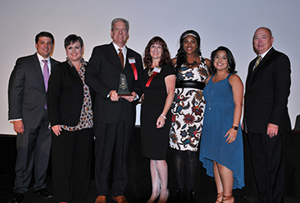
Photo cutline: Massage Envy Tomball receives the 2016 Small Business of the Year Award, Lone Star College-Tomball, at the 30th annual Small Business Awards Banquet. Shown here (left - right) are Amos McDonald, vice chancellor, external affairs Lone Star College; Dr. Lee Ann Nutt, president, Lone Star College-Tomball, who made the presentation; Mack and Michelle Miller, Massage Envy employees; and Dr. Stephen C, Head, chancellor, Lone Star College.

Photo: Photo: LSC_2016SBDCAwardWinners_LSC-UP
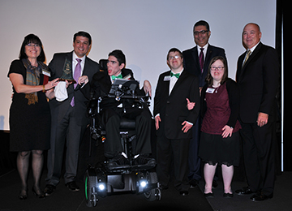
Photo cutline: Shredding on the Go receives the 2016 Small Business of the Year Award, Lone Star College-University Park, at the 30th annual Small Business Awards Banquet. Shown here (left - right) are Renee Parker, Shredding on the Go, Amos McDonald, vice chancellor, external affairs Lone Star College; James Parker; Stephen Sheely; Shah Ardalan, president, Lone Star College-University Park, who made the presentation; Emma Irby; and Dr. Stephen C, Head, chancellor, Lone Star College.

