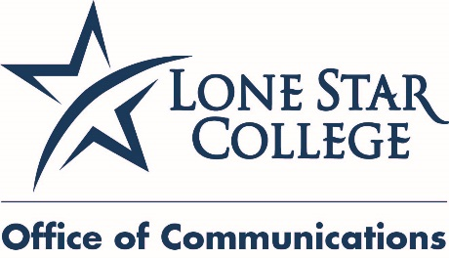

**May 20, 2015**

**FOR IMMEDIATE RELEASE**

Media Contacts:

**Jed T. Young**

832.813.6521, desk

281.974.6878, cell

[Jed.T.Young@LoneStar.edu](mailto:Jed.T.Young@LoneStar.edu)

**Bill Van Rysdam**

832.813.6206, desk

[Bill.VanRysdam@LoneStar.edu](mailto:Bill.VanRysdam@LoneStar.edu)

**Lone Star College Small Business Development Center seeks nominations for awards**

HOUSTON (May 20, 2015) – The Lone Star College Small Business Development Center Advisory Council is now accepting nominations from the community for the 29th Annual Small Business of the Year awards sponsored by BBVA Compass.

“BBVA Compass continues to look for ways to contribute to and support the vitality and economic growth of small businesses across our footprint,” said Amos McDonald, North Houston district retail executive for BBVA Compass. “These entrepreneurs are making significant contributions to our communities and we look forward to recognizing them later this year.”

Each year, members of the LSC-SBDC Advisory Council recognize successful small businesses that have an impact in the local community and economy.  
    
Small-business owners are chosen based on leadership, entrepreneurial spirit, business growth and success, and a meaningful contribution to the community. Three finalists will be selected from each of the six college service areas and ultimately one winner from each college area will be named.

The deadline for nomination entries is June 30.

All 18 finalists will be honored at the 29th Annual Small Business of the Year awards banquet held in November. Nominations may be made by individuals, businesses and organizations.  
    
“One of the reasons Houston’s economy remains strong is the success of the area’s small-business owners,” said Sal Mira, executive director of the LSC-SBDC. “The SBDC is pleased to be able to recognize those businesses that help keep our economy so robust.”

“The Advisory Council has confirmed the criteria for selection of the 29th annual contest. Rules and the nomination process have been simplified which can now be processed totally online,” said Glea Ramey, chairman of the nominations subcommittee of the Advisory Council. [Click here](http://www.lonestar.sbdcnetwork.net/lonestar/Small_Business_of_the_Year.asp) to learn more and nominate a small business.

“Anyone is able to submit names of businesses in the Lone Star College service area they feel are deserving of this recognition and organizations such as banks, accounting firms and local area chambers of commerce are encouraged to nominate businesses,” Ramey said.

The LSC-SBDC works with companies to help them “evolve to the next level of business” and compete in today's global economy. SBDC services are available for companies in every phase of the business life cycle, helping entrepreneurs make sound decisions and succeed. For more information about the SBDC visit [sbdc.LoneStar.edu/.](http://www.lonestar.sbdcnetwork.net/lonestar/default.asp)

Lone Star College has been opening doors to a better community for more than 40 years. Founded in 1973, LSC remains steadfast in its commitment to student success and credential completion. Today, with almost 83,000 students in credit classes, and a total enrollment of more than 95,000, Lone Star College is the largest institution of higher education in the Houston area and one of the fastest-growing community colleges in the nation. Stephen C. Head, Ph.D., is the chancellor of LSC, which consists of six colleges including LSC-CyFair, LSC-Kingwood, LSC-Montgomery, LSC-North Harris, LSC-Tomball and LSC-University Park, seven centers, LSC-University Center at Montgomery, LSC-University Center at University Park, Lone Star Corporate College, and LSC-Online. To learn more visit [LoneStar.edu](http://lonestar.edu).

                                                            ####